**Assignment 7.3:**

**Initial steps:**

* **Import the olympix_data.csv file to /home/acadgild/manjunath/olympix_data.csv folder.**
* **Start mysql server using sudo service mysqld start**
* **Start hive shell using hive command**
* **Use the database custom as created earlier: use custom;**
* **Create olympix table:**

CREATE TABLE olympic_data (athlete string, age int, country string, year int, closingdate string, sport string, goldmedal int, silvermedal int, bronzemedal int, totalmedals int) ROW FORMAT DELIMITED FIELDS TERMINATED BY '\t';

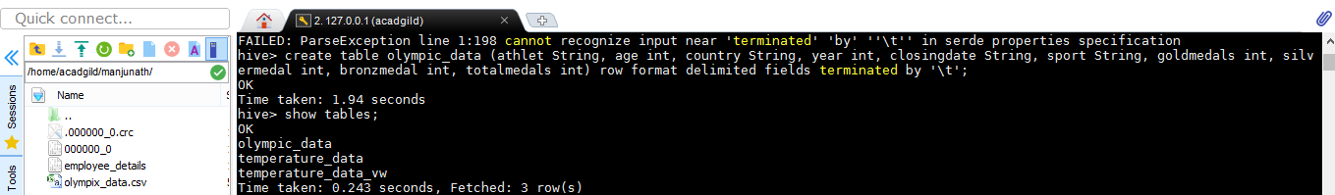

* **Load the olympix_data.csv file into the table.**

Load data local inpath '/home/acadgild/manjunath/olympix_data.csv' into table olympic_data;



**View data loaded into the table:** Select *from Olympic_data;

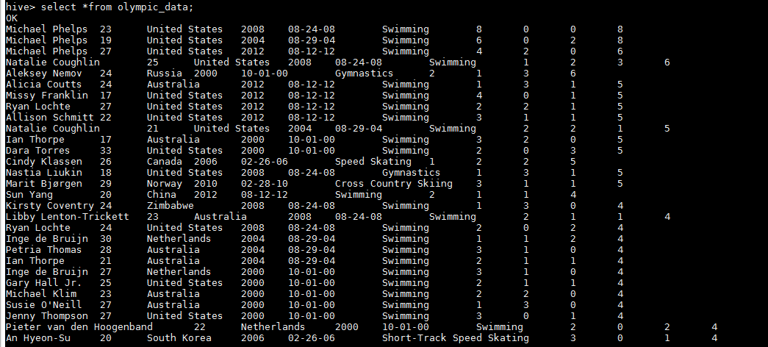

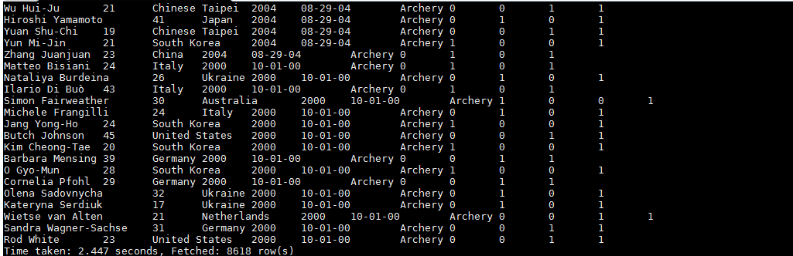

1. Write a Hive program to find the number of medals won by each country in swimming.

Select country, sum (totalmedals) from olympic_data where sport='Swimming' group by country;

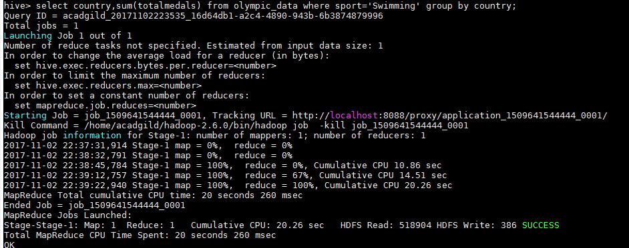

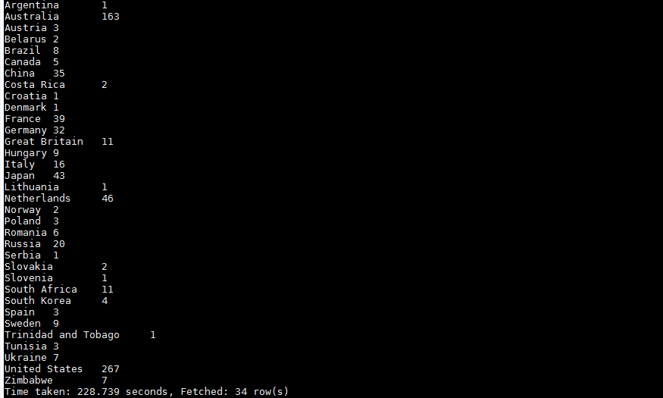

1. Write a Hive program to find the number of medals that India won year wise.

Select year, sum (totalmedals) from olympic_data where country='India' group by year;

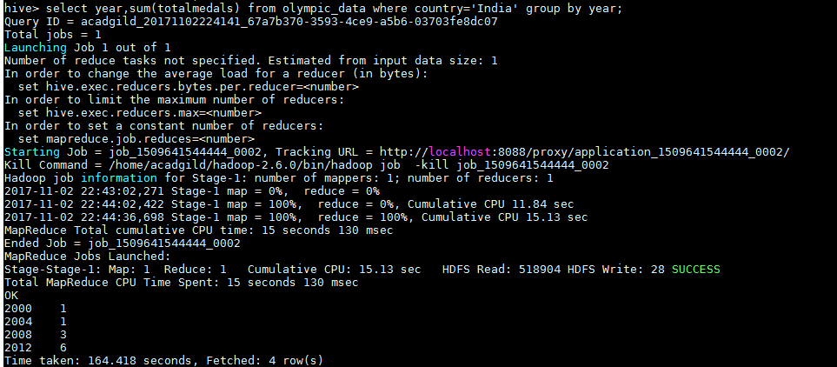

1. Write a Hive Program to find the total number of medals each country won.

Select country, sum (totalmedals) from olympic_data group by country;

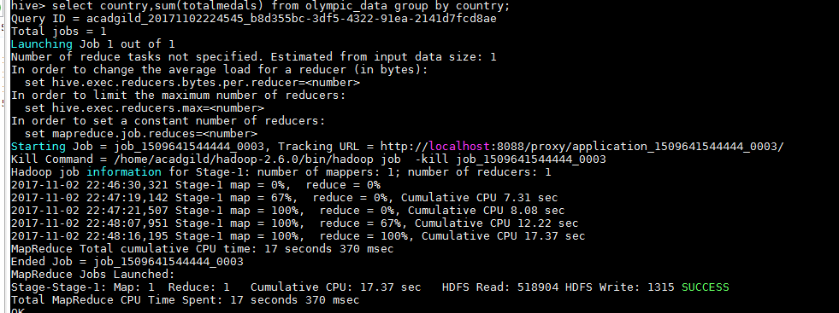

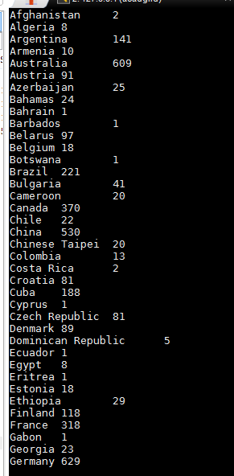

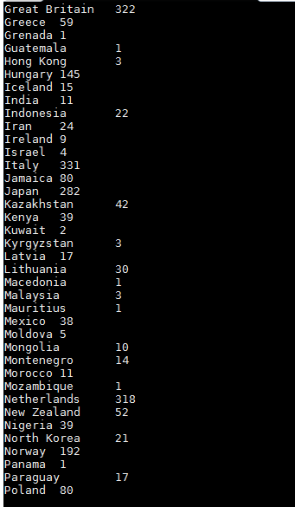

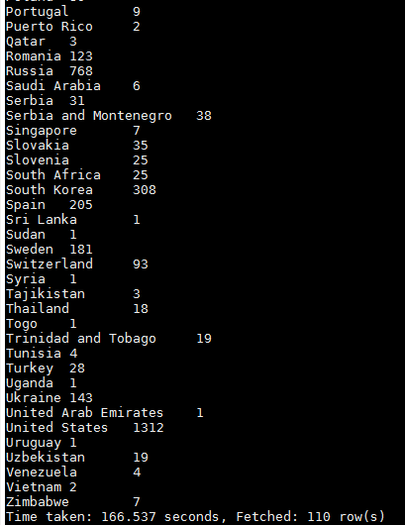

1. Write a Hive program to find the number of gold medals each country won.

Select country, sum (goldmedal) from olympic_data group by country;

